**Blue Ocean:**

Blue Ocean is a new user experience(i.e a new user interface) for Jenkins. It is designed to reduce the clutter and increases the clarity.

It provides an interactive view for Jenkins pipeline( and jobs).

To install Jenkins Blue Ocean:

* Ensure you have Jenkins 2.7 or above.
* Install Blue ocean Plugin.
* Switch to Blue Ocean view. After you have installed the above plugin you will see open Blue ocean icon on Jenkins page.

Below is the view of Blue Ocean.

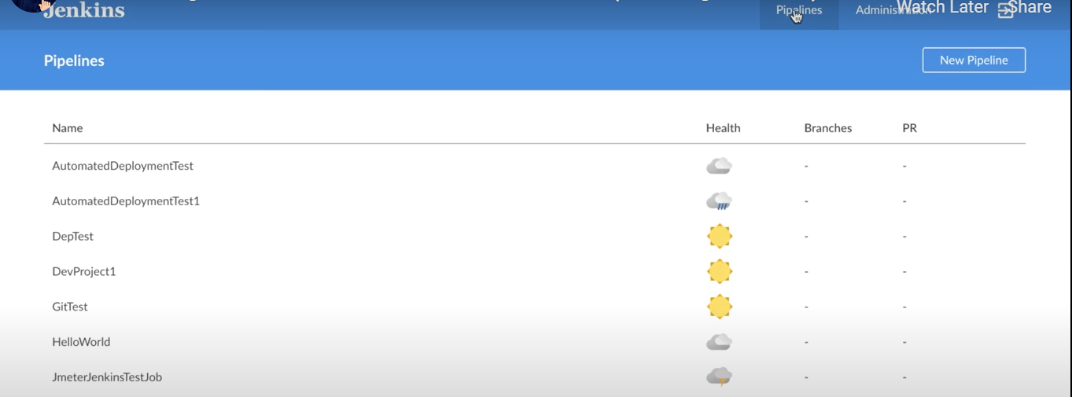

User can switch to Jenkins classic view or Blue ocean view any time.

**How to trigger job with email:**

* Install Plugin “Poll Mailbox trigger Plugin”.
* Now when you create a new job you will see an option ‘poll mailbox trigger’ under build triggers section.
* Now do below configurations as given below:

